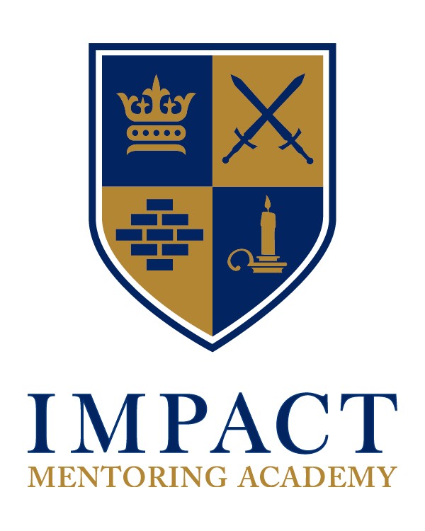
OUR PHILOSOPHY

We believe that every student is created with Unique Potential and has a Designed Destiny. Our approach to education is based upon these two beliefs. We believe that each student has resident within himself, a distinctive arrangement of intelligences, inherited abilities, creativity and dreams. The combination of these creates a myriad of possible outcomes. We believe in Divine Providence and the existence of a parallel invisible spiritual realm to our visible natural reality. As such, we embrace the Guidance of God and trust that He has a plan and purpose for each person’s life (Ephesians 2:10).

We work to see each student that passes through our doors make their unique contribution to the world in which we live and at the same time follow the open-ended, multi-optioned path that has been set out for them by the Divine Father.

IMA MANIFESTO

Our Mission: To challenge and empower teenage males to desire and to complete their senior school education and achieve either college placement or legal employment upon graduation.

Our Vision: We see an emerging generation of young Bermudian males fully equipped for a life of positive impact & productivity.

Our Values:
Humility - We embrace an attitude of learning; we identify and follow legitimate authority.

Community - We choose to live in accountability and in harmony with each other.

Excellence - We honestly endeavor to give our best effort in everything we are and do.

Honor - We learn to live with nobility and truth in whatever circumstances we find ourselves.

Vision - We dream of and identify and goals which are larger than ourselves.

Courage - We dare to face our fears and over them.

Integrity - We adopt an ethic to live in integrity – to be honest and true to our words and actions
Our Goals: To assess each student and assist them in their maturation within the following eight areas (called developmental planes):
Academic comprehension | Trade/Artistic proficiency
Community engagement | Computer competence
Relational aptitude | Entrepreneurialism
Spirituality | Personal integrity

Our Strategy: To create a relationally rich environment where students may be tutored, mentored & inspired through mentoring processes in the eight developmental planes and where parents are supported through information, instruction and accountability.

The curriculum is individualized; i.e. learning style, personality profile, tactile engagement & work orientation. Students learn through conventional as well as innovative/pragmatic methods; i.e. interactive practices, games, exploration & discovery.

MODES OF OPERATION

First Things First
We believe that spirituality is at the core of who we are. Spiritual/moral instruction is, therefore, an important component in our school culture. It is the hub in the center of all our activities. We see the Bible as the primary source of authority for instruction and life governance. We address this area in a non-moralistic/non-denominational/non-sectarian way. Students are related too within the paradigm/belief system which they adhere to and are then encouraged to choose to align themselves with their own family belief system.

Arbinger Method
Each individual has a “way of being” beneath the surface of their behavior. This center of gravity creates possibilities for the person to operate from a position of awareness as a sentient being. This increases relational accountability, self-management and conflict resolution. We have chosen the Arbinger approach as our orientation for our board, our staff, students and parents in this area. All students, parents, and staff are required to attend the one-day Arbinger Seminar – “The Choice in Education” and encouraged to read one Arbinger book (Leadership & Self Deception or The Anatomy of Peace) during the course of the school year. For more information on Arbinger Institute go to www.arbinger.com

Task Orientation
We believe that while equality of the sexes is tenable, males are fundamentally different than females. We recognize that educating males requires a different approach than educating females. Consequently, our method is more geared toward mentoring, as young men tend to respond favorably to this style of leadership.

This also shapes the way our daily activities are structured. Task orientation is the method in which we approach the challenges /assignments of each day. We believe that positive action produces rewards and that males understand this dynamic intuitively. Each student earns their reward/consequence through their own actions and choices.

Our Students Are A Work in Process
In order for each student to discover his unique potential and designed destiny, we encourage curiosity, appropriate experimentation, learning through life experiences, innovative and unconventional avenues. Part of this consists of being able to harness the opportunities that daily events present to us for discovery. We call it a “work in process”. At its best, it is allowing the encounters of life to educate us as we interact with them. Thus we foster learning from a foundation of connection, interaction, and reflection. This means promoting healthy relationships as a way of gaining knowledge and personal growth as well as developing a philosophy of life-long learning.

Mentoring
Circle Time
The morning assembly at IMA is affectionately referred to as “Circle Time”. It is the way that the community begins the day. Circle Time is a group coaching forum with the overarching objectives of personal development and building community through trust. It is also intended to also accomplish the following goals:

Impart the IMPACT philosophy of education
Introduction to Arbinger modality
Foster student ownership in the academy
Facilitate articulation skills
Broaden psycho-emotional capacity
Discuss topics relevant to male development
Model/teach emotional intelligence
Confront & resolve public antisocial behavior

Circle Time is without a doubt one of the key mentoring practices of the academy and the foundation upon which the coaching program is built. The effectiveness of circle time is based upon honest conversation, vulnerability and transparency. This is modeled by the coaching staff to create safe spaces and is required for all regular staff members to attend as far as possible. Boys love “real talk” and trust men who will do it. In this way they learn to take risks to explore their inner and outer worlds so that they can develop into the men they are destined to be.

Group Mentoring
Another key aspect of our mentoring program is where each male teacher is assigned 4 - 6 students and our program provides for periodic interaction to allow for the group mentoring process.

Individual Mentoring
Ultimately mentoring is best facilitated one-on-one. As deemed fit, the appropriately assessed students are matched with a personal mentor with the hope that a trusting bond is developed where wholesome interaction is fostered and direction and insights are provided, especially at this critical point in the lives of our students.

Curriculum
Conventional/Traditional (Mornings)
At IMA we divide our curriculum into two complementary and required designations – Academic and Expeditionary. Academic closely follows left-brain (logical/analytical) activity and learning while expeditionary closely follows right-brain (creative/experiential) activity and learning.

Currently, we utilize three curriculum programs. The LifePac academic curriculum from Alpha & Omega Publishing ais our foundational curriculum offeringprogram. (see https://www.aop.com/curriculum/lifepac). The related subjects are primarily taught in the morning.

Expeditionary (Afternoons)
After lunch the students engage in expeditionary activities. Such activities include, but are not limited to from P.E, Legitsu, Juijitsu, gardening, robotics, industry presentations, music, technical trades, community service, work release, internships, and residential learning expeditions.

Technical Trade Courses (Afternoons)
Each year IMA offers opportunities for students to engage in at least two Technical Trade Courses (i.e. woodwork, auto-mechanics, electrical installation, agriculture, etc.) to gain skills in a tactile discipline. The design is to position our students on two fronts. Through our academic program, we want to position them for tertiary education if they so desire and through the tactile program, we want to position them for workforce readiness.

Community Service
Several local Community Service projects are planned per year – one per school month. Students are empowered to give to the community of which they are a part in a variety of ways and experience personal development as they interact with their socio-ecological environment.

Work Release & Internships
Career/vocational choices can be daunting, even overwhelming at times for many high school graduates who are often under informed about the work opportunities that abound in our small island home. As such, Impact invites speakers throughout the school year to come and present their field, their craft and their passion to our students. This approach is two fold. It allows our students to get an understanding of the many job opportunities that exist and avoid the all too frequent reality of being stuck in a traditional path that does not speak to one’s passion. This also allows us to engage the proverbial village in raising our boys. This industry exposure initiative also allows our males to go on field trips to gain first hand exposure of larger industries and operations.

An integral part of our expeditionary curriculum is our Professional Development Program. Upper senior school students are encouraged to work in an internship of their choice one day per week minimum during terms 2 and 3. This provides an opportunity for work–readiness; to learn and apply knowledge and experiment in a field of interest and possible long-term vocation.

Special Events
Like many institutions, we have the traditional prize giving, honors chapel, graduation program but what sets us apart are our intentional events aimed at bringing out the best in our boys.

Boot Camp
What boy doesn’t like camping. This camp give all an opportunity to see where our boys are at as a new school year begins and is the first step in establishing or reconnect relationship between the faculty and our boys.

Impact Hotel
An evening event where our young men get to don a waiter’s uniform and server family parents and friend. An excellent opportunity to foster hospitality in our boys

Spirit Week
A week aimed at re-emphasizing our first things first mantra of God being the being that we pay acknowledgement to and recognize and pay homage to his divine destiny and plan.

Spoken Word Night
A night where our students get to shine in making performing arts type presentations that serves as a culmination of the public speaking efforts of IMPACT.

Rights of Passage Week-end
A symbolic ceremony that is held annually where our students are taken through a few ceremonial exercises to recognize their movement from one level to the next in the maturity and development of character.

Residential Expeditions
Each year IMA sponsors Residential Expeditions in the form of Camping, Personal Development Intensives and Project Trips to overseas territories. These residential opportunities are required as a part of the expeditionary curriculum and normally last between 3 days and 2 weeks during the school year

.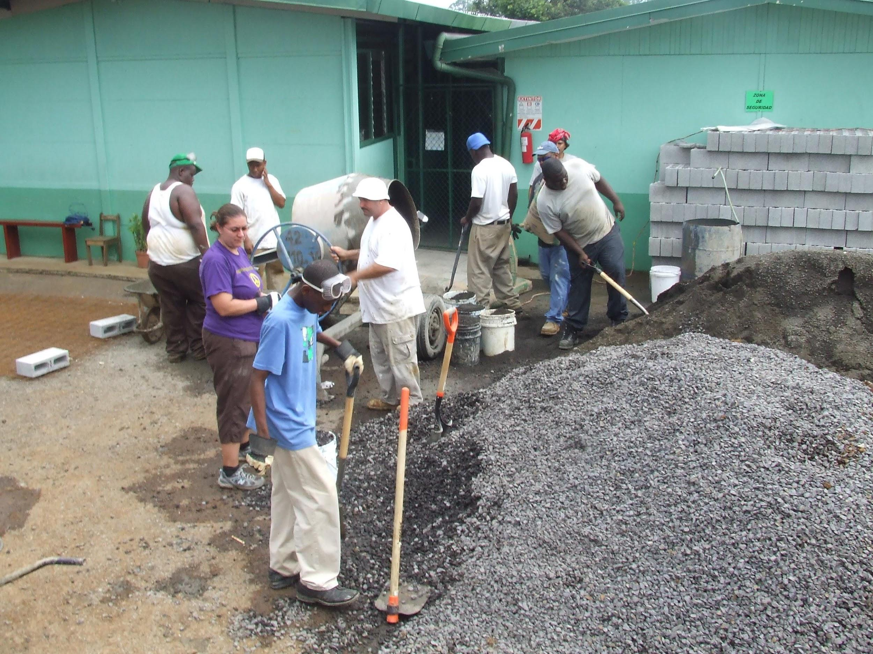
IMA Costa Rica Project Trip 2010

IMA CITIZENSHIP PROCESSES

The IMPACT Level Progress Reports are completed monthly as a way of evaluating a student's progress in his overall program. It helps both he and the staff to see his areas of progress and maturity.

The report breaks down and evaluates seven basic areas of the student’s program and personal development (i.e. academic efficiency, work habit, personality traits, how he relates to others, attitude towards his agreements, attendance, leadership etc.). Each area is averaged together to form his Level Score.

These levels are as follows:

Level 1 - Elemental: (Taker - going through the motions) Staff set expectations; stagnant
Level 2 - Effective: (Doer - student starting to produce results. Expectations are shared) Progressing
Level 3 - Excellence: (Giver - student owns most of the expectation) Self-governed, living responsibility

Privileges may include the following:
Level 3 | - Free seating  - Allowed to leave school at lunchtimes  - Tutorial work opportunities for remuneration  - Job opportunities for remuneration  - Leadership opportunities for remuneration  - Computer privileges during lunch-time
Level 2 | - Semi-free seating  - Allowed to leave school at lunchtimes twice a week (Tues/Thurs)  - Tutorial work opportunities for remuneration
Level 1 | - No privileges  - Assigned seating

Student Leadership
Directly linked to our citizenship program is the development of student leaders. Part of mentoring processes we employ is that of peer mentoring. As such each year we choose students who have exemplified leadership qualities among their peers. Only after maintaining a Level 3 status for at least a term, these student leaders become involved in all of the critical decision-making for the school and assist with maintaining an enjoyable learning atmosphere and wholesome community.

“Champions of Character” House System

Our shield is comprised of four symbols: the crown, the swords, the bricks, and the candle. The crown represents leadership, the swords represent personal development, the bricks represent brotherhood, and the candle represents vision. These symbols represent the four male archetypes and also give us our house symbols.

Daily students will earn points for various things like implementing our values, arriving on time, showing great character, becoming the student of the week/month/term and showing leadership.

At the end of the month, the house with the most points wins the Champions of Character Award. During the last assembly of the month, the house leader will tie the house’s ribbons around the Champions of Character Cup. The house will hold bragging rights for the month as well as a special Grub Day and other incentives.

We expect students in their respective houses to hold each other accountable for their character and performance. Each house has its own color and logo.

IMA ESSENTIALS
1. Respond to adults with “Yes ma’am” or “No sir”
2. Make eye contact when someone is speaking
3. Congratulate the winner or when someone does something well
4. Respect other students’ comments, opinions, and ideas
5. If you win, do not brag, if you lose, do not show anger
6. Do not show disrespect with a gesture
7. Always say thank you when given something
8. Answer all written questions with a complete sentence
9. Do not ask for a reward
10. You must complete your homework every day
11. When homework is assigned, do not moan or complain
12. Know other teachers’ names and greet them in the hall by name
13. Keep yourself and the bathrooms clean and germ-free
14. Stand and greet visitors and make them feel welcome
15. When meeting new people, shake hands and repeat their name
16. When offered food, take only your fair share
17. If someone drops something and you are close to it, pick it up
18. Hold the door for people rather than letting it close on them
19. If someone bumps into you, say excuse me, even if it was not your fault
20. If anyone is bullying you, let us know
21. Learn from your mistakes and move on
22. No matter the circumstances, always be honest
23. Be the best person you can be
24. Honor your school agreements and family commitments

THE STUDENT AGREEMENTS

Attitudinal

1. I agree to come with a posture to succeed.

2. I agree to come with a willingness to cooperate with staff and students (showing respect at all times).

3. I agree to keep an open mind.

4. I agree to respect the principles of the school.

5. I agree to take my education seriously.

Behavioral

6. I agree to attend school regularly.

7. I agree to be punctual.

8. I agree to come dressed in proper uniform.

9. I agree to remain on school premises at all times until dismissed.

10. I agree to complete assigned daily schoolwork before leaving (& leave only by permission)

11. I agree to bring a note or have someone call to be dismissed early for an appointment.

12. I agree to participate in all group activities. (i.e. circle time, assemblies, PE, music, affirmations etc.)

13. I agree to eat only at designated times & in designated areas.

14. I agree to comply with mandatory drug testing procedures.

15. I agree to give my best in all of my school endeavors.

16. I agree to be mentored and coached to discover & develop my Unique Potential.

17. I agree to pursue after my Designed Destiny.

THE PARENT AGREEMENTS

1. I agree to personal development as a parent, including attending the Arbinger orientation seminar.

2. I agree to attend monthly PTA meetings regularly.

3. I agree to attend three Parent Conferences per school year.

4. I agree to hold my son accountable to his Agreements
(including compliance with random mandatory drug testing procedures).

5. I agree to volunteer for an area of support for the school including charitable fund-raising activities.

6. I agree to be punctual at all IMA meetings.

7. I agree to participate in all IMA meetings I attend.

8. I agree to pay tuition and fees on time.

9. I agree to contact IMA Admin if I am unable to make a scheduled meeting or pmt on time.

10. I agree to my son being mentored and coached by IMA to discover & develop his Unique Potential and be deployed into his Designed Destiny.

THE IMA STAFF AGREEMENTS

1. We agree to personal development as staff members.

2. We agree to come with a willingness to cooperate with parents and students.

3. We agree to keep an open mind toward each student/parent/guardian.

4. We agree to model the principles of the school.

5. We agree to take each student’s education seriously.

6. We agree to attend school regularly.

7. We agree to be punctual at all IMA meetings & functions.

8. We agree to come dressed in appropriate attire.

9. We agree to attend monthly PTA meetings regularly.

10. We agree to hold three Parent Conferences per school year.

11. We agree to provide a quarterly Progress Report for each student/parent.

12. We agree to participate in all IMA meetings/activities we attend.

13. We agree to contact other involved parties if we cannot attend a planned meeting or if a meeting time has been changed.

14. We agree to keep regular communication with parents regarding students’ progress.

15. We agree to maintain a high quality of individualized education.

16. We agree to hold students and parents accountable to their respective Agreements.

17. We agree to be held accountable to our Agreements by parents/students.

18. We agree to give our best in all of our school endeavors, maintaining a peaceful, drug-free, learning environment (including our own compliance with random mandatory drug testing procedures).

19. We agree to being mentored and coached to discover & develop our Unique Potential.

20. We agree to pursue after our Designed Destiny individually and as a school.

THE AFFIRMATION

We are men of honor
We are men of vision
We are men of integrity
We are men of courage

Excellence is our goal
Success is our companion
Bermuda is our domain
The world is our oyster
And our contribution to it
will certainly be made

I am here for a purpose
My life has deep significance
I have arrived on schedule for my assignment
The world is a better place
because of my presence in it

I AM A MAN OF IMPACT!
THE BENEDICTION

Whoever you are
Be noble

Whatever you do
Do well

To whomever you speak
Speak kindly

And bring joy
Wherever you dwell

________________________________

IMA Faculty

Principal Shayne Scott

Executive Assistant Chelsea Jacobs

Science Keevon Holdipp

Math Sergio Pitcher

English Stephanie Hendrickson

Social Studies Ryan Nesbitt

Religion Pastor Germiko Hill

Physical Education Ryan Nesbitt

Art/Tutor Christine Atcheson

Facilities & Industry Rep Victor Gilbert

IMA Board

President Calvin CC White

Vice President Pastor Joseph Whalen

Secretary Orlando Smith (Kassandra Hayward)

Treasurer Cornell Fubler

Members George Cook III (Alumni)
Norma Trott (HR)
Timothy Jackson (Curriculum)
Valancia Swan (AML)

